Capstone Looker

Task 1. Get started with Looker
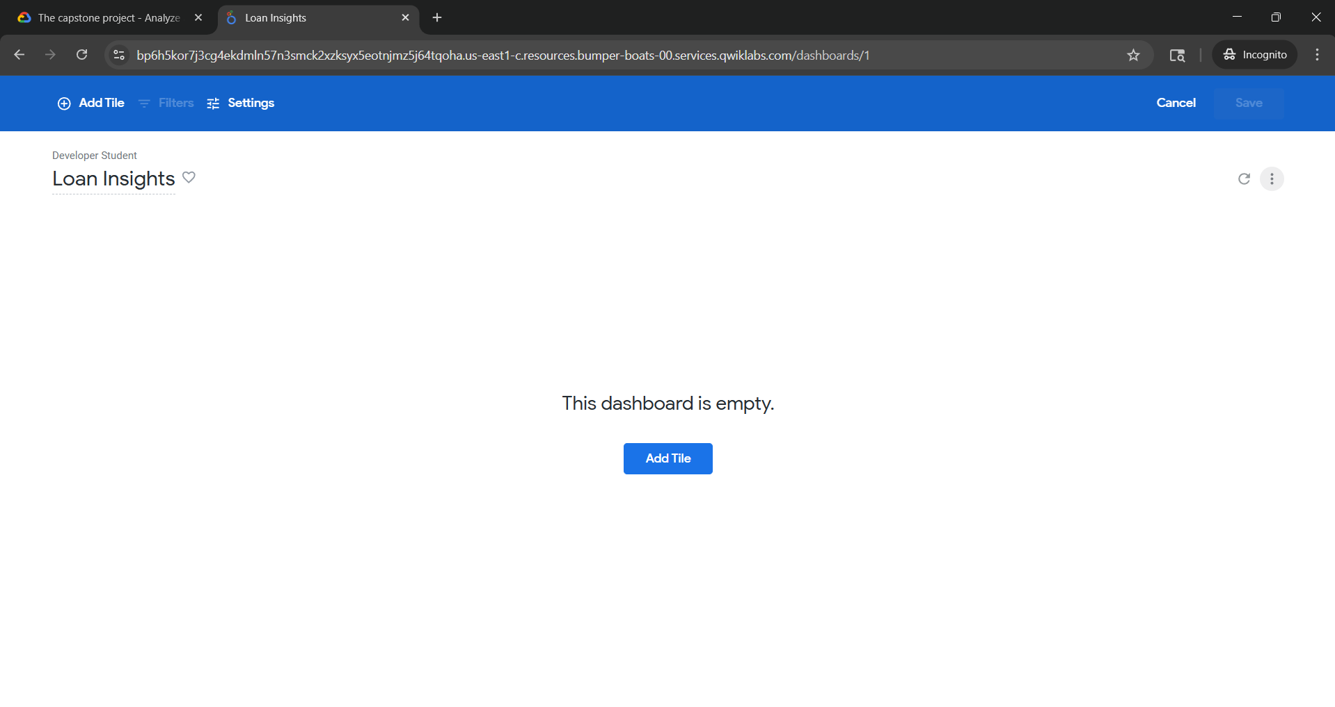
Task 2. Build a visualization that displays the total amount of all outstanding loans
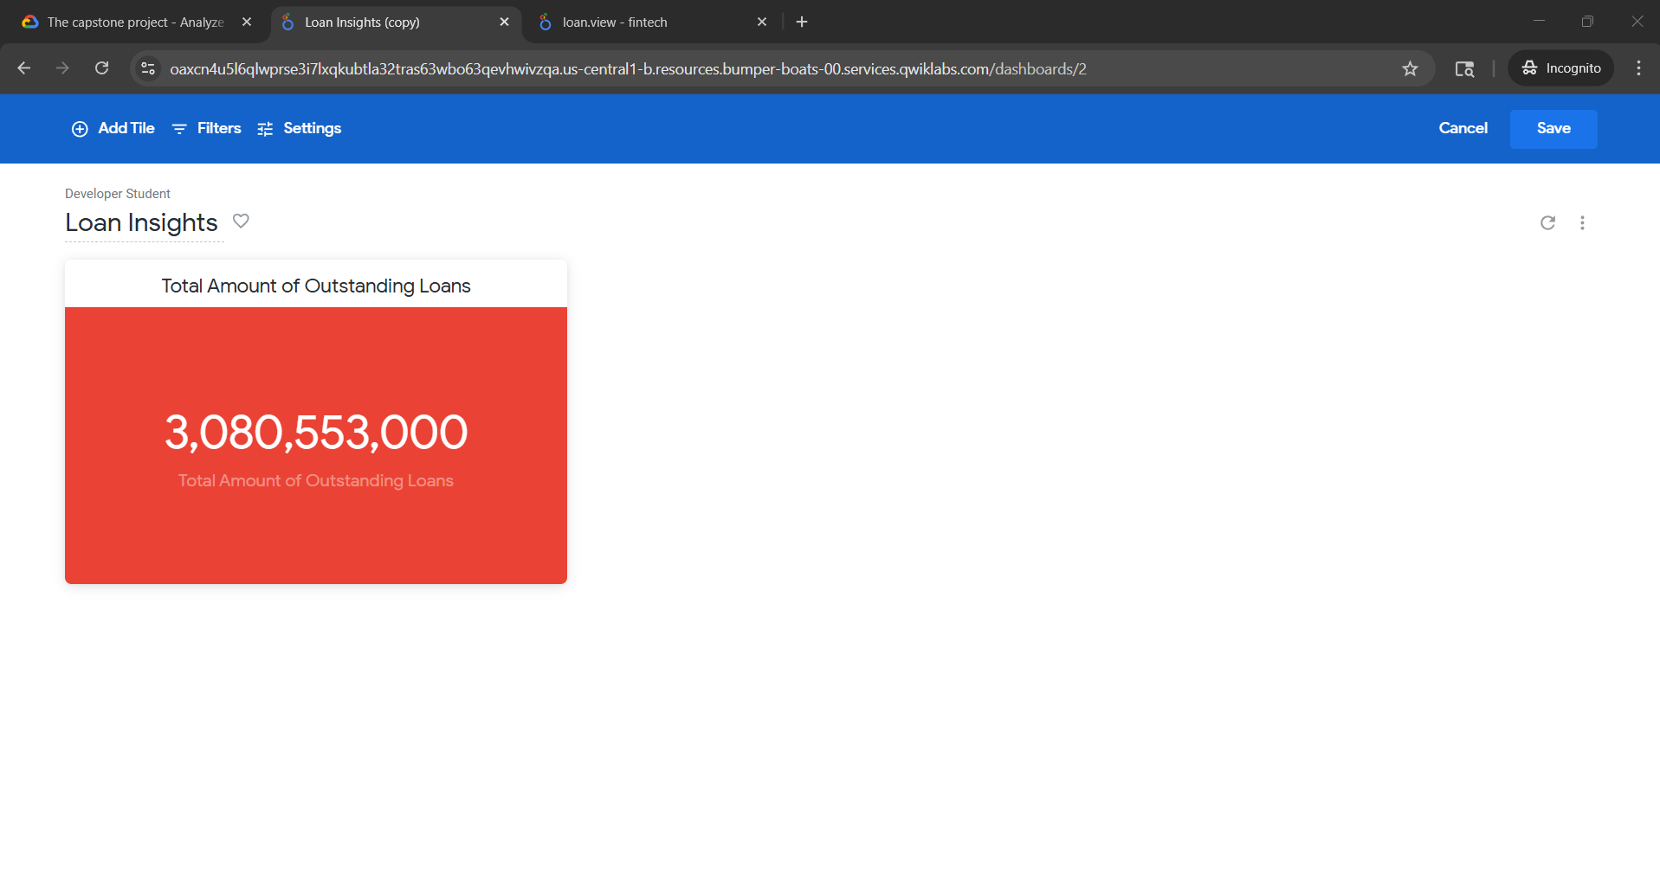

Task 3: Build a visualization that displays the percentage of outstanding loans in each status
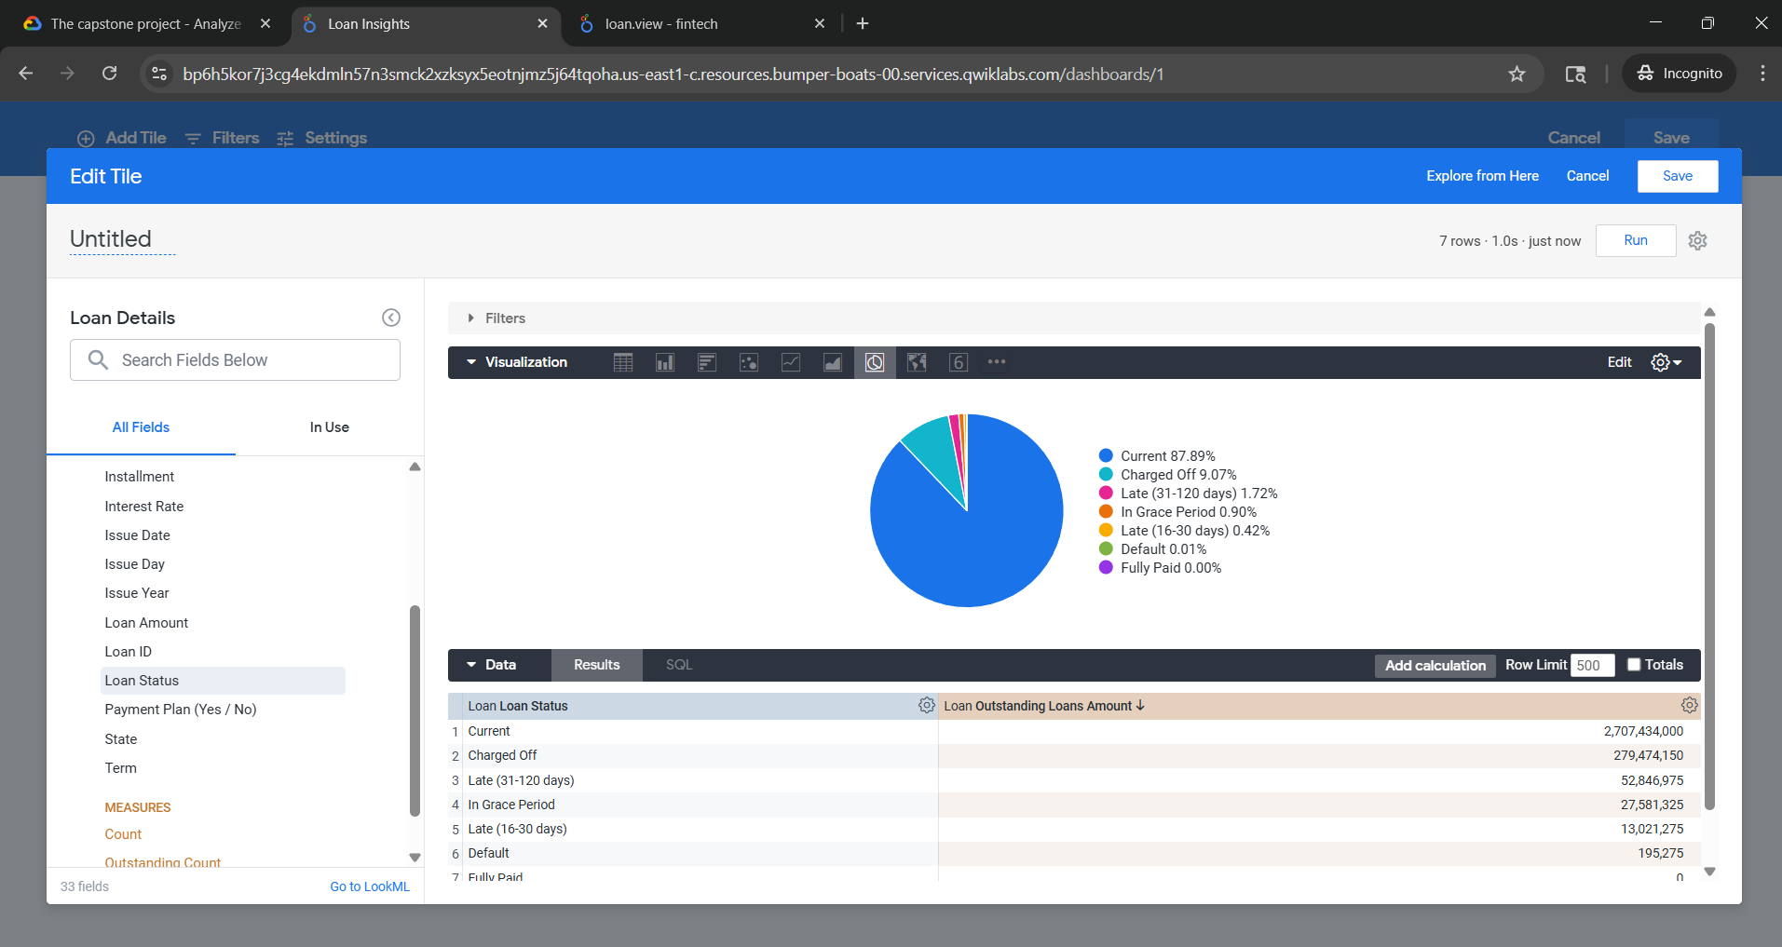

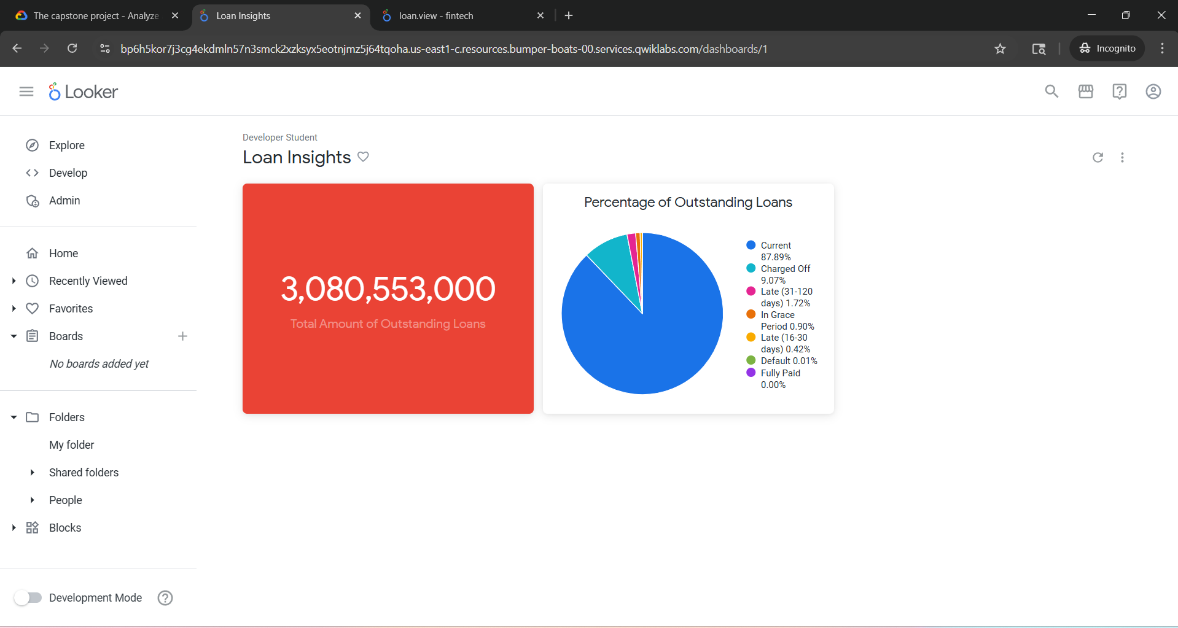
Task 4: Build a visualization that displays the total count of outstanding loans for each state

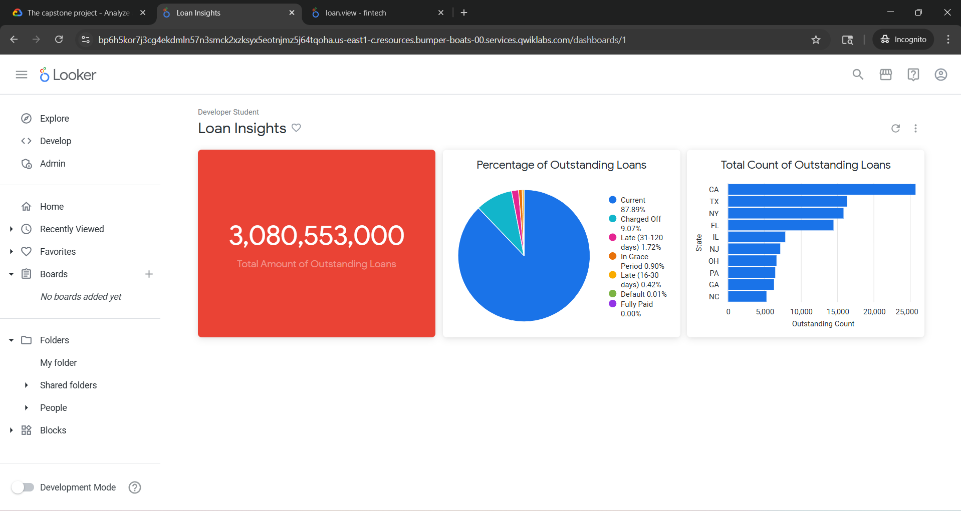
Task 5: Build a visualization that displays top 10 customers by highest income
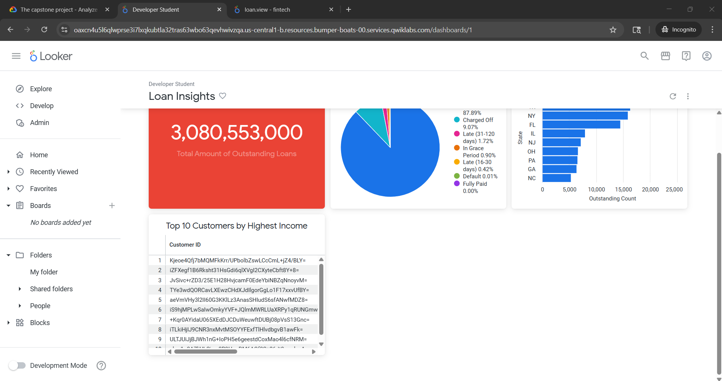

Task 6: Add functionality to the dashboard
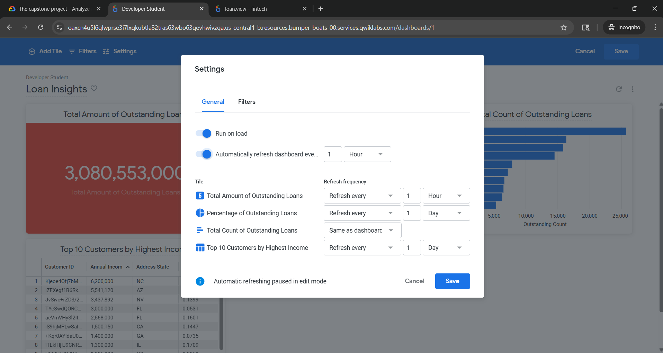
Task 7: Optimize dashboard
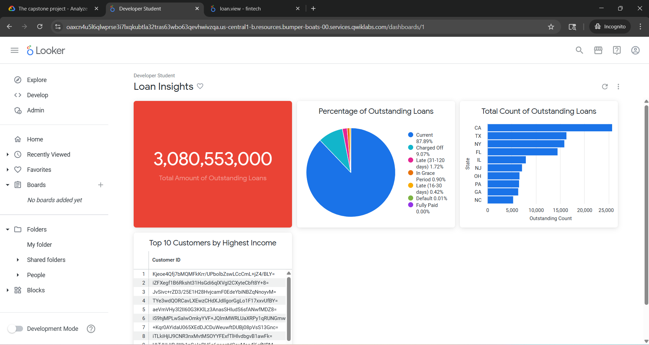

Task 8: Share dashboard

https://oaxcn4u5l6qlwprse3i7lxqkubtla32tras63wbo63qevhwivzqa.us-central1-b.resources.bumper-boats-00.services.qwiklabs.com/dashboards/1
